Tammy Kothe-Ramsey
Licensed Professional Counselor
Email: tammy.kothe@gmail.com
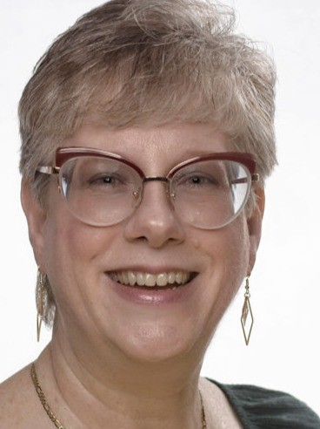
Address: 12336 Claiborne, San Antonio, TX 78252
Phone: 830-444-5064
Date of birth: Jan 22, 1967
Nationality: American
Link: https:/ www.linkedin.com/in/tammy-kothe-
ramsey-m-a-lpc-49ab9325/

OBJECTIVE Experience Licensed Professional Counselor with a passion to assist individuals and families to heal from generational hurts.

EXPERIENCE
Hondo, TX
Jan 2022 - Present

Hondo, TX
Dec 2017 - Nov 2021

Castle Hills, TX
Jan 2014 - Sep 2019

San Antonio, TX
Jun 2014 - Oct 2017

Licensed Professional Counselor
TKR Counseling Services PLLC

Assess needs and develop recovery plans for children ages 3-12, adolescents, and adults. Facilitate individual and family sessions with trauma-informed, strength-based interventions utilizing Play Therapy, Solution Focused, and Cognitive Behavioral Therapy techniques.

FAYS Family Counselor
K'STAR Youth and Family Services

Assess needs and develop recovery plans for individuals and families with children ages 0 to 17 residing in Medina County, TX. Determine appropriate crisis intervention, if necessary, facilitate intervention approach, and counsel family through the process.
Facilitate individual and family sessions to address identified concerns. Conduct outreach measures to create awareness of services available to community.

Grief Share Group Facilitator
Mission City Church
Facilitated weekly grief support group meetings for the church community. Presented video seminars and facilitated discussion sessions based on a 13-week faith-based curriculum.

Selected Contributions:
Assisted group member in achieving peer co-facilitator status as a result of mentoring and completing group counseling sessions.

Clinical Practitioner II
The Center for Health Care Services
Provided direct and clinical care to children ages 5 to 17 in the Crisis Respite Residential Center. Assessed needs, created safety plans, and developed recovery plans for those admitted to the Crisis Respite Residential Center and those seeking services through the Crisis Clinic, Open Access Clinic, and through the Crisis Mobile Outreach Team.
Determined appropriate crisis intervention services, facilitated intervention approach, and counseled family through the process.

Evaluated ability to fund hospitalization for patients without insurance. Managed cases, oversaw medication, and documented progress of each patient in the Anasazi EMR system. Facilitated individual and group skills training.

Selected Contributions:
Gained further protection and supported legal action through reporting sexual abuse to Child Protective Services for a client of the Crisis Mobile Outreach Team.

Secured a $250 grant through the internal giving campaign by writing and submitting a proposal for assistance.

EDUCATION
San Antonio, TX
2013 - 2015

San Marcos, TX
2011 - 2013

San Antonio, TX
2008 - 2011

M.A. in Counseling
Wayland Baptist University

Two-year program focused to equip passage of state board exam for counselors with curricula on theories, practices, and techniques. Included practicum and intern assignment locations to implement classroom learning.

B.A. in Psychology
Texas State University

Undergraduate program with focus on Psychology and Forensic Psychology.

A.A. in Psychology
San Antonio College

Required core curricula with a focus on Psychology and Criminology.

SKILLS

- Play Therapy
- Sandtray Therapy
- Cognitive Behavioral Therapy
- Trauma Informed Care
- Trust Based Relationship Intervention
- Brief Solution Focused Therapy
- Gottman Method for Couples

